Dynamic Daytona Beach District
Lay Organization
African Methodist Episcopal Church

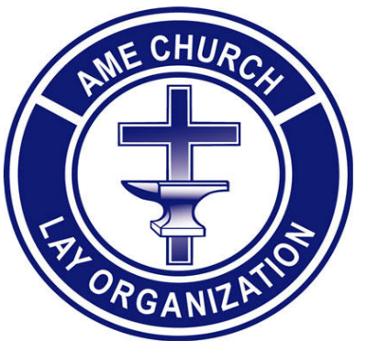

THE
DDBD BOOK SCHOLARSHIP
Guidelines and Application

Bishop Marvin Clyde Zanders, II
11th Episcopal District Presiding Prelate

Rev. Dr. Lorenzo Laws
Dynamic Daytona Beach District Presiding Elder

Mr. John Love
Episcopal Lay President

Mr. Earl Burney
Central Conference and DDBD Lay President
Page 1

DYNAMIC DAYTONA BEACH DISTRICT LAY ORGANIZATION
AFRICAN METHODIST EPISCOPAL CHURCH

Dynamic Daytona Beach District Book SCHOLARSHIP
_____________________________________________________

Dear Applicant:

The Dynamic Daytona Beach District Lay Organization supports the mission and objectives of the Eleventh Episcopal District and the Connectional Lay in the pursuit for training, motivating, and encouraging educational development.

Consideration will be given to applicants meeting the following criteria:

- Must be a member of the Dynamic Daytona Beach District (DDBD) African Methodist Episcopal Church.

- Must be a senior graduating from a public or private school in the Dynamic Daytona Beach District.

- Must have a minimum cumulative grade point average of 2.5 on a 4.0 academic scale or its equivalent upon graduation. Applicants must submit current, unofficial transcript, showing cumulative grade point average.

- Upon graduation, applicants must submit to the DDBD level an official high school transcript showing graduation date and cumulative grade point average.

- Must enroll as a full-time student in a college, university, or an accredited trade school by the Fall of the year the scholarship is awarded.

- Two letters of recommendation are required - one (1) from the applicant's pastor, YPD Director, or Bible Discovery Superintendent and one (1) from a school official of the applicant's high school.

- The applicant must submit a 200-word essay explaining what it would mean to be the first recipient of the Dynamic Daytona Beach District Lay Book Scholarship. Only electronically submitted essays will be accepted. Please send your essays as a word document without the assistance of AI.

Page 2

- APPLICANT MUST MEET ALL REQUIREMENTS IN ORDER TO BE CONSIDERED A CANDIDATE FOR THE DAYTONA BEACH DISTRICT LAY SCHOLARSHIP. REQUIRED INFORMATION NOT COMPLETED AND SUBMITTED WILL INVALIDATE THE APPLICATION.

- ALL APPLICATIONS, CURRENT TRANSCRIPTS, ESSAYS AND LETTERS OF RECOMMENDATIONS MUST BE SUBMITTED TO THE DDBD CHAIRPERSON, SISTER FANNIE MILLER BY EMAIL ON APRIL 30, 2026.

- You will email your information to:

Ms. Fannie Miller – millierich5@yahoo.com

If you have any questions or need clarification, please contact the chairperson, Ms. Fannie Miller by email at millierich5@yahoo.com.

We are excited and we hope you are also. Awesome individuals like you make our district the Dynamic Daytona Beach District.

The Dynamic Daytona Beach District Lay Book Scholarship Committee Members Are:

Sister Annie Johnson Sister Lonnie Ford Sister Vickie Presley
Sister Amicita Maloon-Gibson Sister Lee Fowlkes Brother Valene Croskey
Sister Fannie Miller

*This scholarship is based on the Selmo-Bradely model.

Page 3
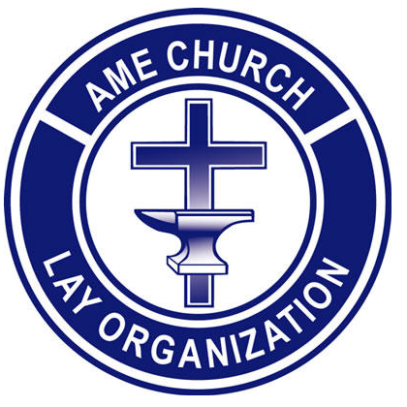

The Dynamic Daytona Beach District
Book Scholarship Application

ELECTRONICALLY SUBMIT ALL INFORMATION. THE SIGNATURE PAGE MAY BE SCANNED AND UPLOADED.

PERSONAL DATA

Name:

Address:

City/ State/ Zip Code:

Home Phone: E-Mail Address:

Date of Birth:

CHURCH INFORMATION

Church Membership:

Address:

Telephone Number: E-mail Address:

Pastor: Local Lay President:

Page 4
CHURCH PARTICIPATION

(include local church, district, conference and Episcopal involvement (attach additional page(s) if needed).

ACADEMIC INFORMATION

High School:

High School Address:

Telephone Number:

SCHOOL INVOLVEMENT

(attach additional page(s) if needed)

College/University you plan to attend (first choice)

College/University you plan to attend (second choice) _____________ _________________

Trade School you plan to attend:

Intended major course of study:
Honors/Awards (attach additional page(s) if needed)

Cumulative Grade Point Average (scale 4.0 or equivalent)
Page 5

COMMUNITY SERVICE

(attach additional page(s) if needed)

FAMILY INFORMATION

Name:
Parent/Guardian (Relationship)

Parent/Guardian's Signature Date

Parent/Guardian (Type Name) Date

Parent/Guardian: Contact Telephone Number_____________________________________

Parent/Guardian: Email Address: _______________________________________________

SCHOLARSHIP APPLICANT: I HAVE REVIEWED THE APPLICATION CAREFULLY TO ENSURE THAT ALL INFORMATION IS VALID AND COMPLETE.

Signature – Scholarship Applicant Date

Scholarship Applicant (Type Name)

Revised: March 2026

- This application is based on the Selmo Bradely Lay model.

Page 6

